

CSA0501-DATABASE MANAGEMENT SYSTEMS

LAB EXPERIMENTS DATE: 29/07/2026

EXPERIMENT 16 – HIGH LEVEL PROGRAMMING EXTENSIONS - PROCEDURES

AIM: To implement stored procedures in MySQL using the milka_dairy table to retrieve records and determine the customer level based on the amount.
PROCEDURE:
- Create the milka_dairy table and insert the required records.
- Use the CREATE PROCEDURE statement to create a new stored procedure.
- Specify the procedure name after CREATE PROCEDURE.
- Use the DELIMITER command to change the standard MySQL delimiter from ; to //.
- Create a procedure named GetAllMilkRecords() to retrieve all records from the milka_dairy table.
- Use the SELECT statement inside the procedure to display all records.
- Change the delimiter back to ; after creating the procedure.
- Execute the stored procedure using the CALL command.
Your original problem uses customer number and customer level, but your table doesn't have those columns. We can create a similar problem using your name and amount columns.

Problem 1

Create a simple stored procedure to get all the records from the table milka_dairy.

Problem 2
Your original problem uses customer number and customer level, but your table doesn't have those columns. We can create a similar problem using your name and amount columns.

Problem
Create a stored procedure GetMilkCustomerLevel() that accepts two parameters: customer name and customer level. The procedure should get the amount supplied by the customer from the milka_dairy table and determine the customer level based on the amount.
Use the following conditions:
- Amount >= 1000 → PLATINUM
- Amount >= 600 → GOLD
- Amount < 600 → SILVER

Problem 3:
Create a stored procedure to display the customer name, liters and amount for customers supplying more than 8 liters of milk.

PROGRAM -1:

Create a simple stored procedure to get all the records from the table milka_dairy.

DELIMITER //

CREATE PROCEDURE GetAllMilkRecords()
BEGIN
SELECT * FROM milka_dairy;
END //

DELIMITER ;

CALL GetAllMilkRecords();
OUTPUT:

Desc milka_dairy
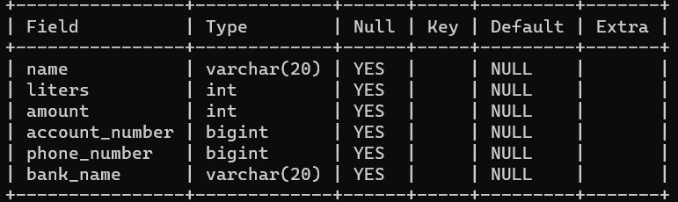

PROGRAMM -2

DELIMITER //

CREATE PROCEDURE GetMilkCustomerLevel(
IN p_name VARCHAR(20),
OUT p_customerlevel VARCHAR(20)
)
BEGIN
DECLARE v_amount INT;

SELECT amount
INTO v_amount
FROM milka_dairy
WHERE name = p_name;

IF v_amount >= 1000 THEN
SET p_customerlevel = 'PLATINUM';
ELSEIF v_amount >= 600 THEN
SET p_customerlevel = 'GOLD';
ELSE
SET p_customerlevel = 'SILVER';
END IF;
END //

DELIMITER ;
CALL GetMilkCustomerLevel('Kamala', @level);
SELECT @level;

1)Amount >= 1000 → PLATINUM

OUTPUT:

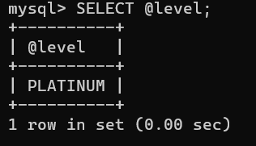

2)Amount < 600 → SILVER

CALL GetMilkCustomerLevel('Shanthi', @level);
SELECT @level;
OUTPUT:
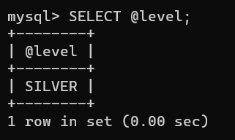
3)Amount >= 600 → GOLD
CALL GetMilkCustomerLevel('Sugana', @level);
SELECT @level;

OUTPUT:

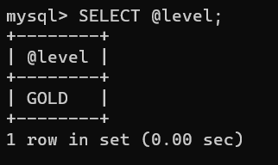

PROBLEM-3

Create a stored procedure to display the customer name, liters and amount for customers supplying more than 8 liters of milk.

DELIMITER //

CREATE PROCEDURE GetHighMilkSuppliers()
BEGIN
SELECT name, liters, amount
FROM milka_dairy
WHERE liters > 8;
END //

DELIMITER ;
CALL GetHighMilkSuppliers();
OUTPUT:
